When You Wore Braces
Access Guide

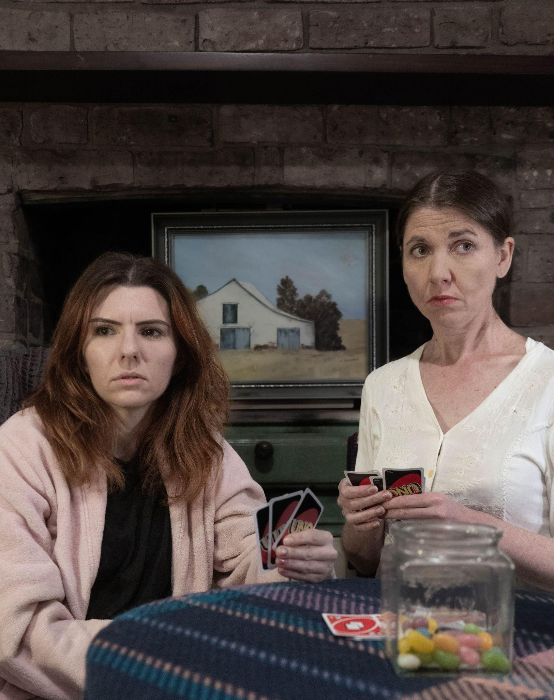

Introduction and contact information:

When You Wore Braces is a new one act play by Rachel Edmonds. This is its debut run and it has been produced independently by the artists involved. It is being performed from the 25th to the 30th of July Bluestone Church Art Space in Footscray, Melbourne.

This is an access guide for all things relating to this season of performances, including the venue and getting to the venue.

If you require further information, Production Coordinator DL Turnbull can be contacted at theatrecat@live.com.au

*Please note there is currently construction happening next door to the venue. We do not know what stage they will be at by the time the show is on. We have timed our shows with this in mind, to avoid peak construction times.*

Contents:
Introduction 2
Getting there (Public Transport/Parking) 3-4
Venue Access (Wheelchair access/bathrooms) 5
Sensory Information (Building design/Quiet Spaces/Permissions) 6-7
Event Access (Sound/Lighting/Trigger Warnings/Auslan Interpreted Date) 7-8
Covid Safety 8
Relaxed Performance 9
Fat Access Information (Chair width/Comfort options) 9-10
Performers (Photos) 10

Getting there:

The Bluestone Church Arts Space is located at 8a Hyde Street, Footscray VIC

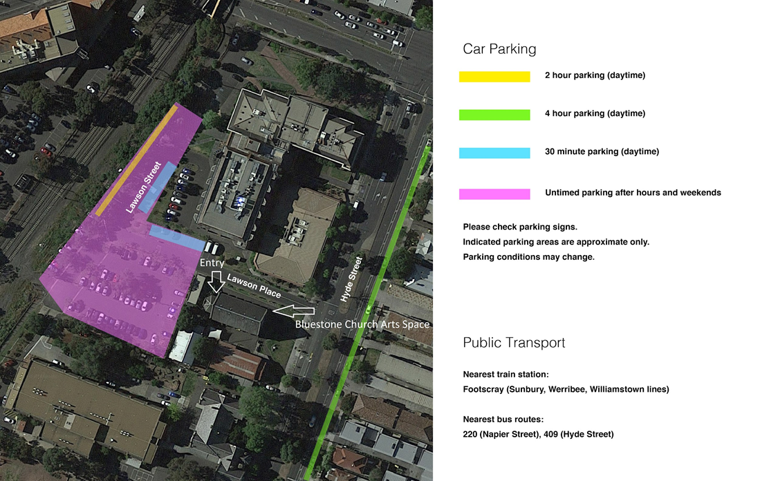
Image is a graphic of parking and entry at the venue. Relevant information is detailed below.

Public Transport:

Nearest train station: Footscray train station. 8 Minute walk (Google maps timing).

Nearby bus routes: 409, 223 & 220.
Bus stops: Hyde street & Napier Street.

Visit https://www.ptv.vic.gov.au/ for more information.

Parking:

Private car park entry via Hyde Street. It is a council car park during the day and has ‘staff only’ signs upon entry. Please ignore these as the show is only on outside of staff permit times. Check the individual parking signs.

There is an accessible park located next to a ramp at the front of the car park.
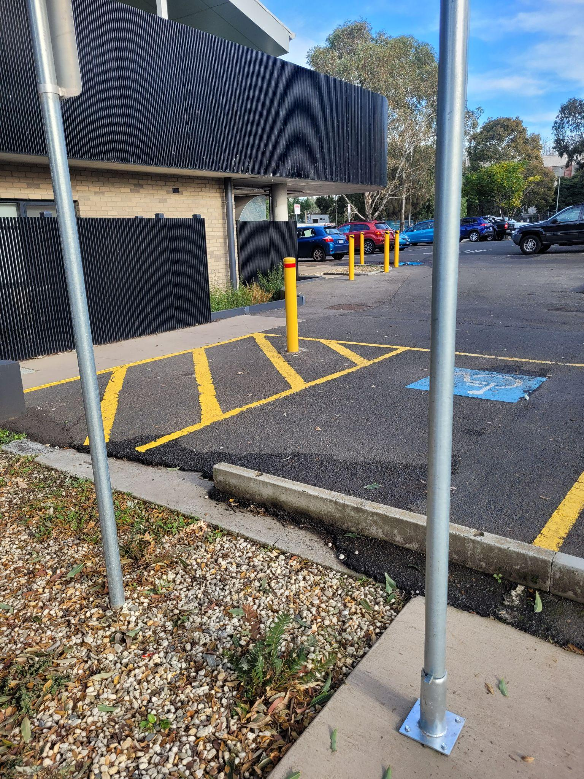

Image of accessible car park with transfer space

Limited off-street parking available on Hyde Street.

Venue Access:
Entry: Although, there is a main entry at the front of the church, all entry for this show will be via the door closest to the car park. If entering from the street, come down the pathway to find the door. The pathway is very wide.
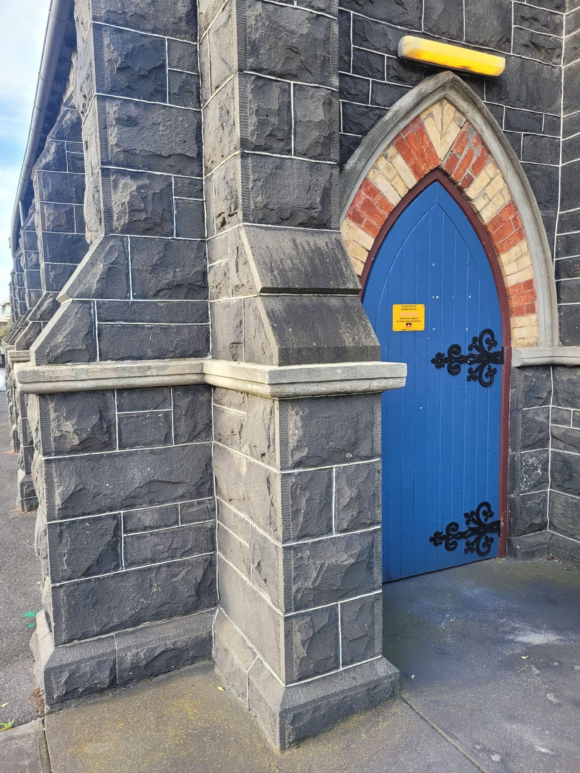
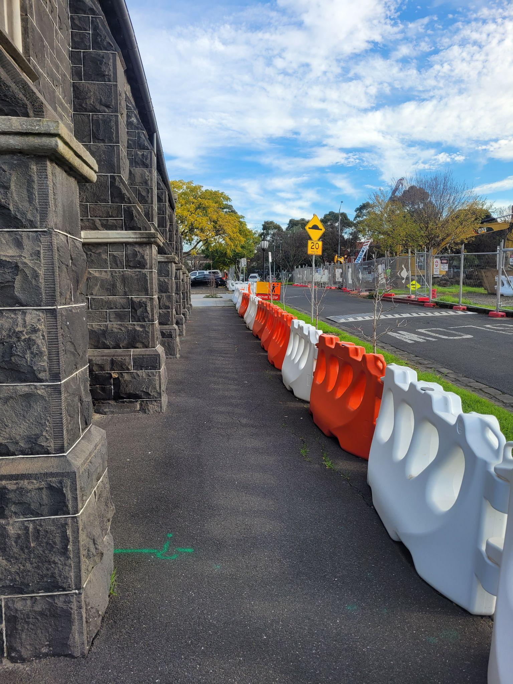

Left image is the pathway to the entry. Right image is the entry door.

Wheelchair accessibility includes: Ramp access to building & accessible bathroom within the Bluestone Church Arts Space. The bathroom access is on the tighter side for an accessible bathroom but manageable. We would recommend using a wheelchair rather than a mobility scooter for getting into the toilet space.

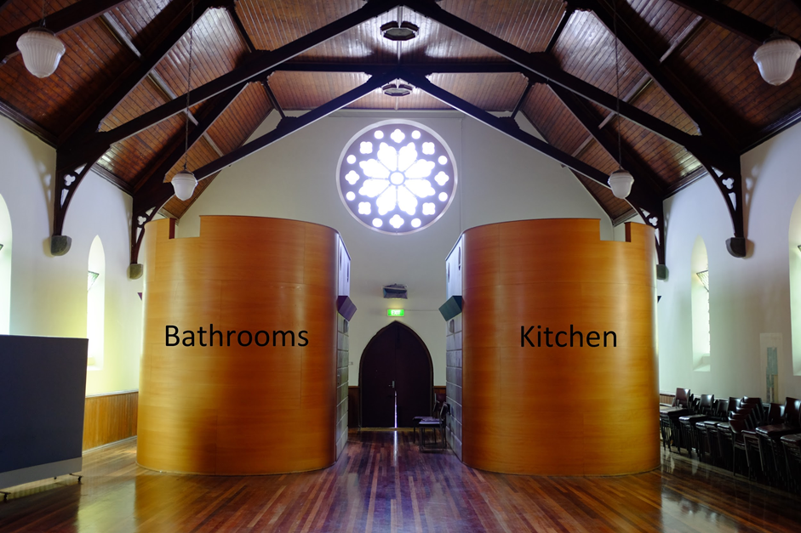

Image of the hall from the entry. Left is labeled bathrooms, the right is labeled kitchen.

Sensory Information:

Venue Design: The venue is a medium size repurposed church. It can be quite loud with everyone talking prior to a show.

The following section contains general information regarding the preview performance and 8pm performances on the Thursday, Friday, Saturday and the 4pm performance on the Sunday. The 2pm Saturday performance is a relaxed performance and will have a different set of information.

Permissions:

-Any stimming or stim devices that are quiet and do not disturb the performers.
-Permission to remain seated following the performance for up to 10 minutes.
-Any reasonable adjustment required for comfort or disability. Example: exiting to the bathroom, bringing a pillow.
-Eating and drinking during the show. However, we would appreciate no loud packet opening during the show.

Quiet Spaces: There will be two spaces (weather dependent). One space is outside and the other is inside. The outdoor space is directly outside the building. There is a small courtyard area with seating near the car park. There may be some surrounding noise traffic. The indoor space will be at the far end of the building, past the bathrooms, and hence there will be some noise leak from the show. There will be seating there also.

Event Access:

Show Length: 50 minutes. No interval.
Auslan Interpreted show: Saturday the 29th of July at 2pm
Lighting: Basic lighting. No strobe effects
Sound: Mostly dialogue. Minimal use of sound effects and music.

Trigger Warnings *Contains Spoilers*
Red = Major theme/reference
Orange = Medium reference
Purple = Minor reference

- Themes of death, including historical accidental death of a teenager, suicide ideation and description of a covering up a crime.
- Religious references and appropriation
- Swearing
- Mentions of car accident and texting while driving
- Mentions of historical sexual assault (no details)
- Dialogue around pain and disability
- Slut shaming
- Mild biphobia themes
- Mention of underage drinking

Covid safety:

For the safety and security of our immune compromised cast, crew and audience members we respectfully request the wearing of masks.

Masks will be provided.

Should covid impact the cast during the run. Shows will be either canceled or postponed and ticket holders will be contacted via email.

We request that you do not attend if you have a confirmed case of covid19. Please test prior to attendance if you have symptoms. Any concerns around tickets, please contact the production co-ordinator at theatrecat@live.com.au

Relaxed Performance:

Saturday 29th July, 2pm
- Auslan interpreters
- Touch tour available from 1pm to 1.20pm
- Neutral/natural lighting
- No loud sound affects
Performance begins at 2pm but audiences can enter and leave as they need. Though they are asked to consider the viewing experience of other audience members to the best of their ability as Deaf/HOH community members will need to see the interpreters.

Quiet Spaces: There will be two spaces (weather dependent) that you can go to-and-fro during the show. One space is outside and the other is inside. The outdoor space is directly outside the building. There may be some surrounding noise traffic. The indoor space will be at the far end of the building, past the bathrooms, and hence there will be some noise leak from the show. You will be welcome to come and go from both these spaces as you please during the performance. An usher will be available to assist and direct you.

Permissions
- Stimming and stimming tools (such as fidget spinners)
- Exiting and reentering the space during the show
- Latecomers welcome
- Eating and drinking
- Humming -Rocking
- Bringing pillows, blankets etc into the space
- Whatever you need within reason

Fat Accessibility Information:

Chair Width - *information coming*

If you require extra room either side of your chair this can be arranged. If you would be more comfortable bringing your own chair this could potentially be arranged (space allowing). Please email theatrecat@live.com.au if you require assistance in this regard.

Performers:
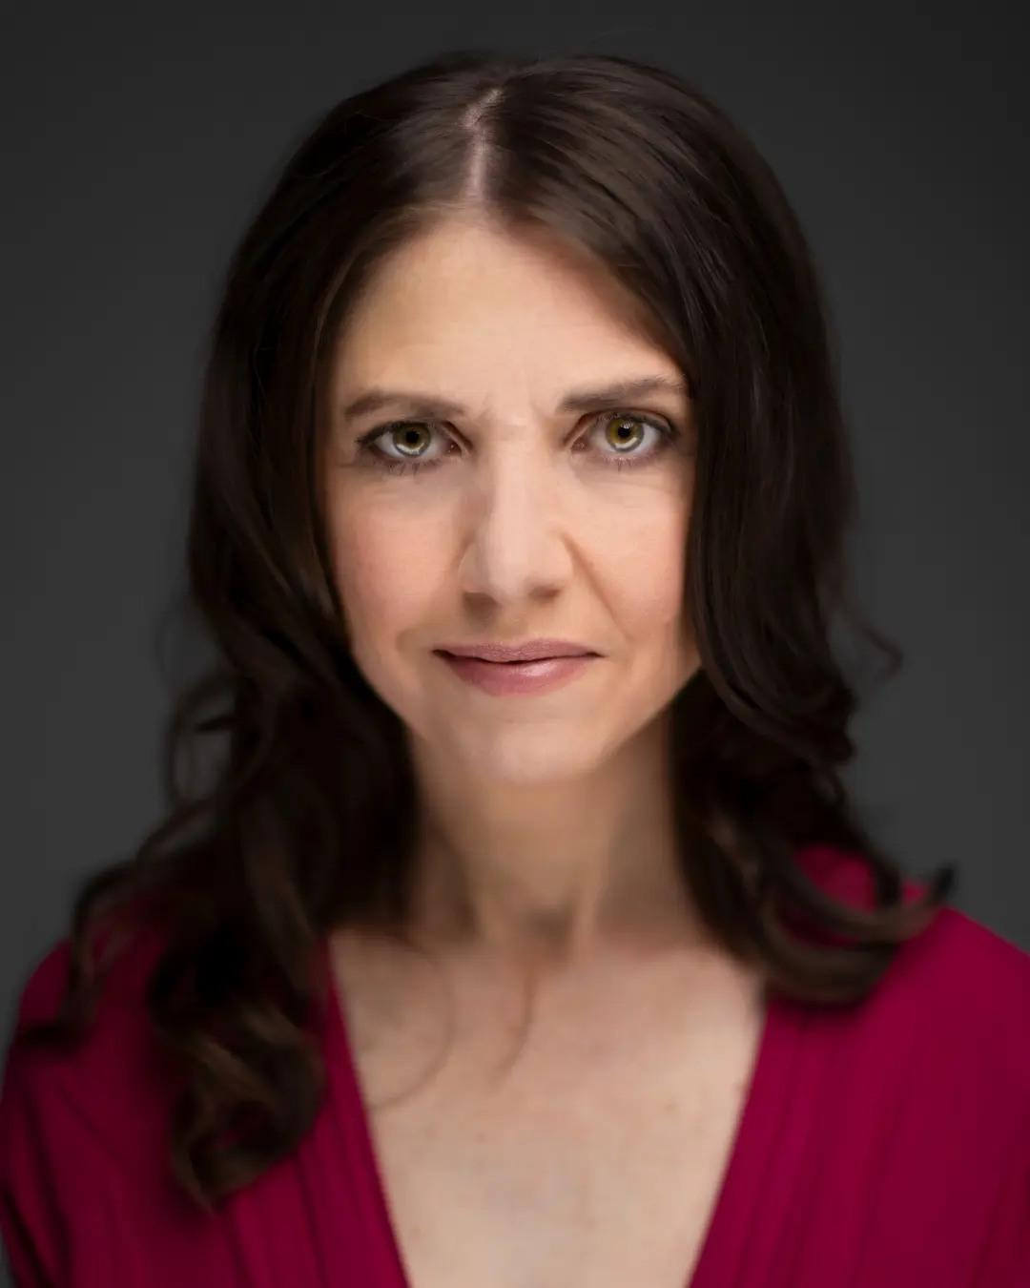
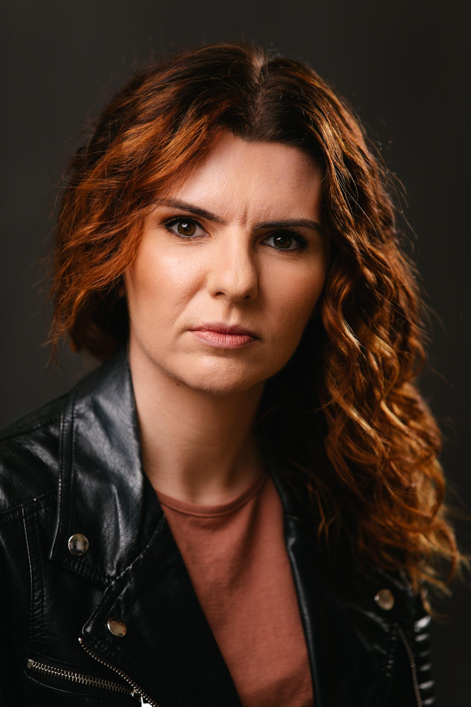
Rachel Edmonds playing Lily Sonia Marcon playing Paige

